Supercapacitors for Power hold up
A growing demand to support maintenance free power loss can simply be met with the latest generation of VINATech Supercapacitors from Farnell.
Offering much longer life and fast response than conventional battery methods, the supercapacitor solution is becoming the first choice in the professional market such as Manufacturing equipment, Medical, Communications and PC Uninterruptible power supplies.
Try the VINATech 360F 3V VEC3R0367QG or the 500F 3V type VEC3R0507QG, these are the most suitable product for creating a power bank for short term power loss from 1~5 seconds. The 3V series offers much longer life than conventional 2.5 or 2.7V types and reduces the component count, the best solution for Peak Power assist on the market to date.
Other applications also include Power Back-up start up for Fuel Cells and power compensation for Critical applications during periods of unstable power delivery.
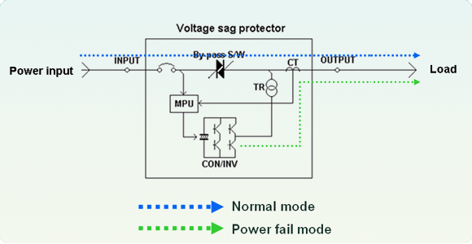
Other applications for thi

